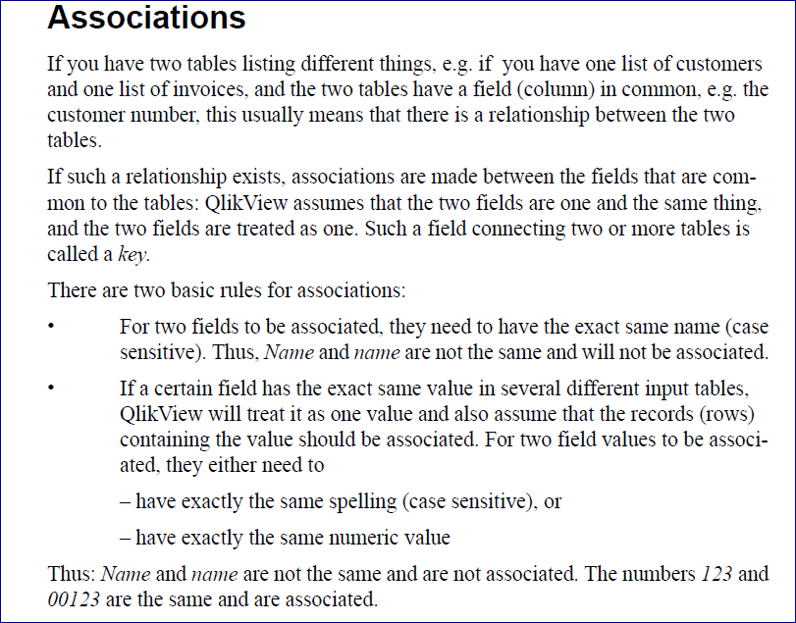

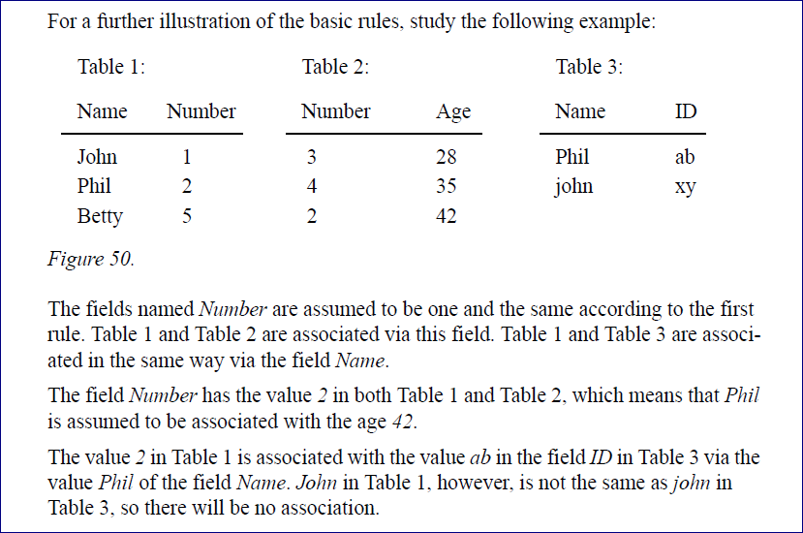

Table1:   
**Load** * Inline [   
Name, Number  
John ,1  
Phil, 2  
Betty, 5  
];  
  
  
Table2:   
**Load** * Inline [   
  
 Number ,Age  
3,28  
4,35  
2,42];   
  
Table3:  
**Load** * Inline [   
  
Name, ID  
Phil ,abc  
John,xyz  
];

